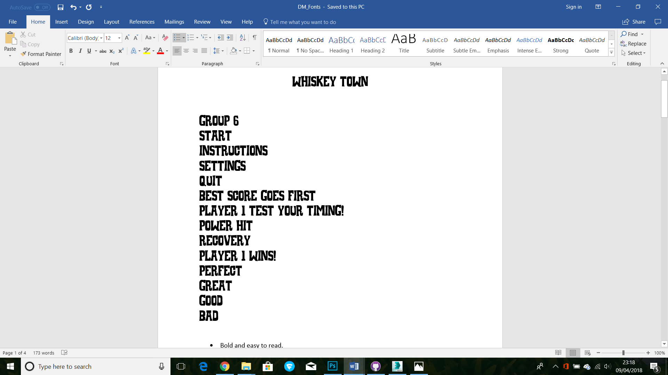

* Bold and easy to read.
* Western theme with a playful/cartoonish look to it.

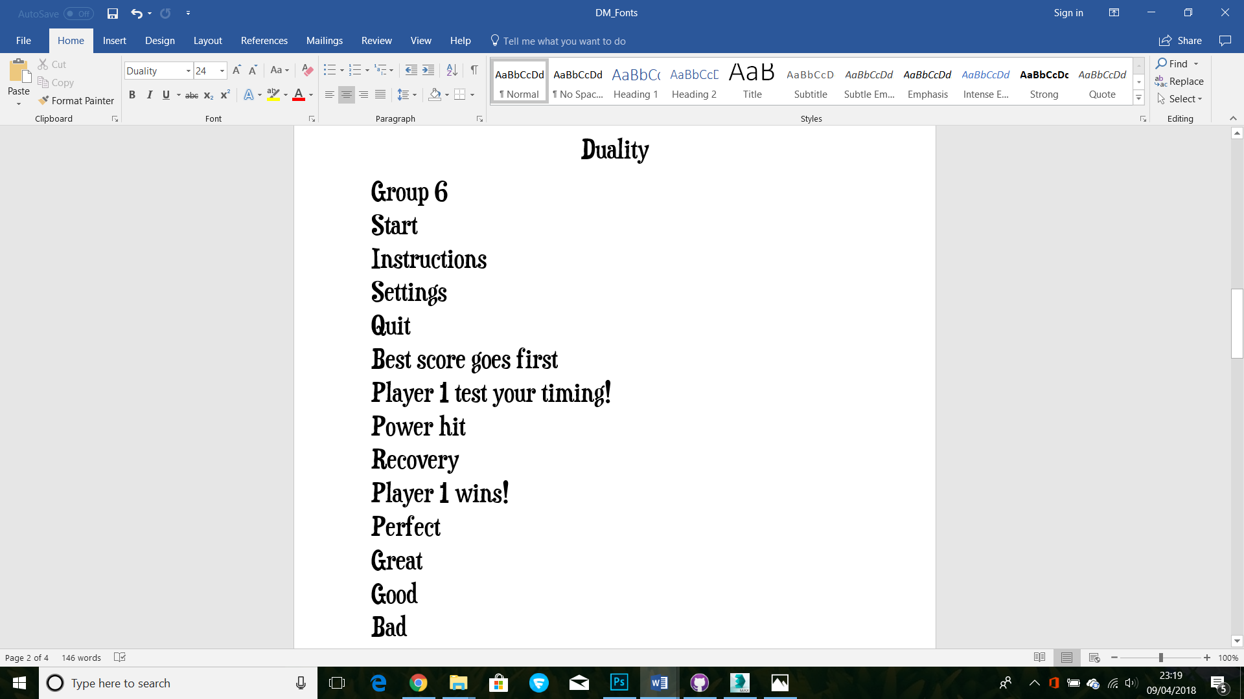

* Subtle, less cartoon style but still playful.
* Clearly read and neater.

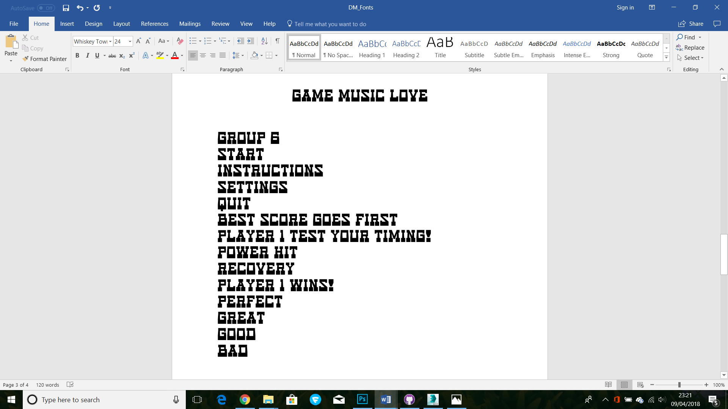

* Retro game style while still fitting the western theme.
* Bold but may not be easily read if appears quickly in game.

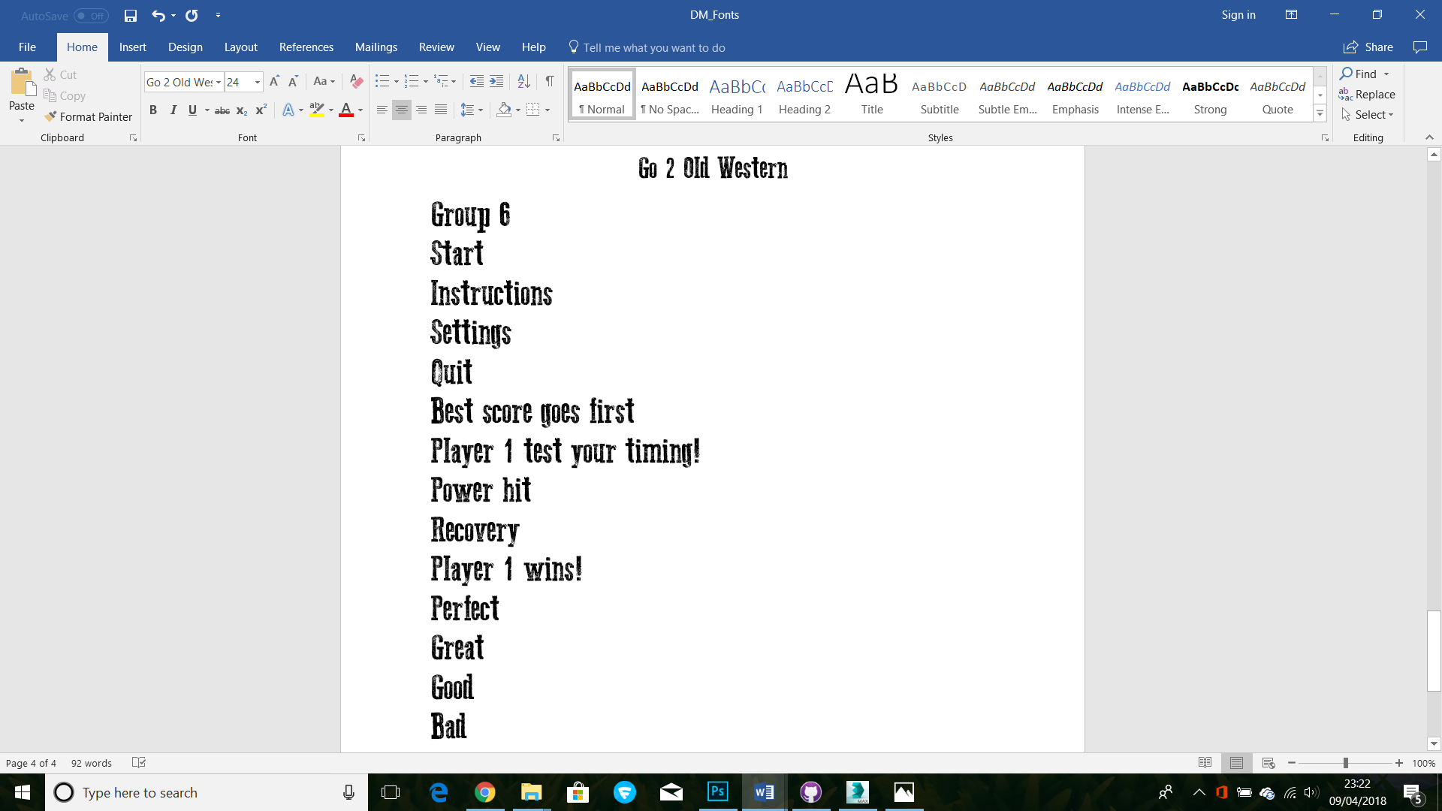

* Grittier western themed font.
* Bold and clear to read but may not fit the tone of the game?